LAB PRACTICUM: OpenMP Multi-Core Scaling in Python
Hands-Off Benchmark Practicum • 60 Minutes • Autonomous Execution
Student Name:Nurailym Nurlankyzy Student ID:230103071
Hardware / CPU: inteli7 Intel64 Family 6 Model 191 Stepping 2, GenuineInte
Date & Section: 2.10.2026

�� LAB PROTOCOL & AUTONOMOUS RULES OF ENGAGEMENT
1. Autonomous Session: You are expected to read, run, optimize, and document all findings independently.
2. Zero Support for Dependency Issues: If you encounter an error, verify that you installed packages inside a clean virtual environment. Compilers are NOT needed for this lab. 3. Equal Hardware Standard: Keep your laptop plugged into wall power and close background browsers, video streams, or games to prevent CPU thermal throttling and frequency capping. 4. Whiteboard Leaderboard: When you finish Task 1 and Task 3, record your CPU model and best speedup factor on the lab whiteboard.
1. Background & Environment Setup (10 Minutes)
Standard CPython executes bytecode under the Global Interpreter Lock (GIL), preventing multiple CPU threads from executing simultaneously in Python space. In this lab, we bypass the GIL using Numba's JIT compiler with its native multithreaded OpenMP/TBB work-stealing engine. Because Numba compiles numeric Python loops directly to machine code and releases the GIL inside parallel loops (prange), we achieve bare-metal native CPU scaling across both macOS (Apple Silicon M-series) and Windows/Linux x86_64 machines with zero local C++ compiler dependencies.
Execute the following in your terminal / command prompt:
pip install numpy numba matplotlib

Instructor – sufyan.mustafa@sdu.edu.kz
2. Challenge 1: The Core Speedometer & Amdahl's Law
Objective: Benchmark an embarrassingly parallel Monte Carlo simulation to approximate π across varying thread counts. You will measure execution latency, quantify parallel speedup, and observe where Amdahl's Law caps performance.
import time
import numpy as np
import numba
from numba import njit, prange
print(f"Hardware Threads Detected: {numba.config.NUMBA_NUM_THREADS}")
@njit(parallel=True)
def monte_carlo_pi(n_samples):
inside_circle = 0
for i in prange(n_samples):
x = np.random.uniform(0.0, 1.0)
y = np.random.uniform(0.0, 1.0)
if x * x + y * y <= 1.0:
inside_circle += 1
return (4.0 * inside_circle) / n_samples
# JIT Warmup (excludes JIT compilation overhead from benchmarks) _ = monte_carlo_pi(10_000)
SAMPLES = 120_000_000
thread_counts = [1, 2, 4, 8, numba.config.NUMBA_NUM_THREADS]
# Filter out duplicates and invalid counts
thread_counts = sorted(list(set([t for t in thread_counts if t <= numba.config.NUMBA_NUM_THREADS])))
print(f"{'Threads':<10} | {'Time (s)':<12} | {'Speedup':<10} | {'Efficiency (%)':<15}")
print("-" * 55)
t1_baseline = None
for t in thread_counts:
numba.set_num_threads(t)
start = time.perf_counter()
pi_est = monte_carlo_pi(SAMPLES)
elapsed = time.perf_counter() - start
if t == 1:
t1_baseline = elapsed
speedup = 1.0
efficiency = 100.0
else:

Instructor – sufyan.mustafa@sdu.edu.kz
speedup = t1_baseline / elapsed
efficiency = (speedup / t) * 100.0
print(f"{t:<10} | {elapsed:<12.4f} | {speedup:<10.2f}x |
{efficiency:<15.1f}")

Deliverables & Technical Questions for Challenge 1:
• A. Record your baseline T_1 (1 thread) and your maximum multi-thread runtime T_max in Table 1 below.
• B. Why is the warm-up call _ = monte_carlo_pi(10_000) strictly required before recording benchmark timings?
• C. Did your parallel efficiency stay at 100% when scaling from 1 to max threads? What architectural factors (e.g. memory bus contention, hyperthreading/SMT core vs physical core limits) explain the degradation?
• D. Why does inside_circle += 1 inside prange not corrupt the count? What implicit OpenMP reduction construct does Numba generate here?
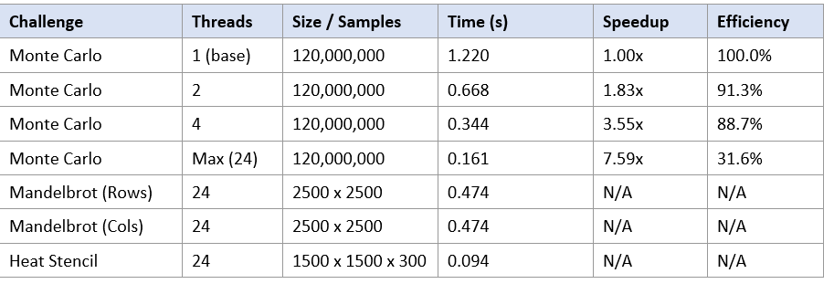

A. T_1 = 1.220 s (1 thread). T_max = 0.161 s (24 threads).
B. Numba compiles lazily, on the first call. Without the warm-up, the first timed run would include JIT compilation (seconds) and thread-pool startup, which would swamp the actual compute time. The 10,000-sample call forces compilation first, so later timings measure only the loop.
C. No. Efficiency fell steadily: 91% (2 threads), 89% (4), 80% (8), then 32% (24). Causes:
(1) Hyperthreading/SMT: two hardware threads share one physical core and add only about 25% throughput.
(2) Hybrid cores: efficiency cores are slower than performance cores.
(3) Clock speed: turbo frequency drops under all-core load, and thermal/power limits cap it further.
(4) Serial work: thread launch, RNG setup and the final reduction are serial, as Amdahl's law says (speedup <= 1 / (s + (1-s)/N)).
(5) Memory bus contention is negligible here because Monte Carlo is compute-bound. Going from 8 to 24 threads only reduced time from 0.191 s to 0.161 s.
D. Numba recognizes inside_circle += 1 as a reduction variable. Each thread gets a private copy initialized to 0, and the copies are summed once after the loop. This is equivalent to OpenMP's reduction(+:inside_circle), so there is no race on a shared variable.

Instructor – sufyan.mustafa@sdu.edu.kz
3. Challenge 2: Load Imbalance & Dynamic Scheduling
Objective: Compute a high-resolution 2500×2500 Mandelbrot fractal. Unlike Monte Carlo, points in the complex plane require radically different amounts of compute: points inside the set iterate all the way to max_iter , while outer points escape in 2-3 iterations. You will investigate how non-uniform workloads impact thread utilization.
import time
import numpy as np
import matplotlib.pyplot as plt
from numba import njit, prange
@njit(parallel=True)
def render_mandelbrot_rows(h, w, max_iter):
img = np.zeros((h, w), dtype=np.int32)
# Row-parallel loop
for r in prange(h):
cy = -1.2 + (r / h) * 2.4
for c in range(w):
cx = -2.0 + (c / w) * 2.5
z_real, z_imag = 0.0, 0.0
it = 0
while (z_real * z_real + z_imag * z_imag <= 4.0) and (it < max_iter):
next_real = z_real * z_real - z_imag * z_imag + cx z_imag = 2.0 * z_real * z_imag + cy
z_real = next_real
it += 1
img[r, c] = it
return img
@njit(parallel=True)
def render_mandelbrot_cols(h, w, max_iter):
img = np.zeros((h, w), dtype=np.int32)
# Column-parallel loop (swapped iteration axis)
for c in prange(w):
cx = -2.0 + (c / w) * 2.5
for r in range(h):
cy = -1.2 + (r / h) * 2.4
z_real, z_imag = 0.0, 0.0
it = 0
while (z_real * z_real + z_imag * z_imag <= 4.0) and (it < max_iter):
next_real = z_real * z_real - z_imag * z_imag + cx z_imag = 2.0 * z_real * z_imag + cy
z_real = next_real
it += 1

Instructor – sufyan.mustafa@sdu.edu.kz

img[r, c] = it
return img
# Warmup JIT
_ = render_mandelbrot_rows(100, 100, 50)
_ = render_mandelbrot_cols(100, 100, 50)
H, W, MAX_IT = 2500, 2500, 1000
t0 = time.perf_counter()
grid_rows = render_mandelbrot_rows(H, W, MAX_IT)
t_rows = time.perf_counter() - t0
t1 = time.perf_counter()
grid_cols = render_mandelbrot_cols(H, W, MAX_IT)
t_cols = time.perf_counter() - t1
print(f"Row-Parallel Render Time: {t_rows:.3f} s")
print(f"Column-Parallel Render Time: {t_cols:.3f} s")
# Save visual artifact
plt.figure(figsize=(8, 8))
plt.imshow(grid_rows, cmap='magma', extent=[-2.0, 0.5, -1.2, 1.2]) plt.title(f"Mandelbrot {H}x{W} (Render: {t_rows:.2f}s)")
plt.axis('off')
plt.savefig('mandelbrot_output.png', dpi=300, bbox_inches='tight') print("Saved image: mandelbrot_output.png")

Deliverables & Technical Questions for Challenge 2:
• A. Compare t_rows vs t_cols . Which axis decomposition completed faster on your machine and why?
• B. Explain how NumPy's C-contiguous (row-major) memory layout interacts with CPU cache lines when threads write to img[r, c] vs img[c, r] .
• C. Load imbalance analysis: If thread 0 receives the top 20% of rows and thread 2 receives the center 20% of rows, why does one thread idle while the other struggles? How does OpenMP dynamic scheduling resolve this?
• D. Attach your exported mandelbrot_output.png file alongside your completed task sheet.

A. Rows and columns tied at 0.474 s. Mandelbrot is compute-bound (up to 1000 iterations per pixel, one write each), so the memory access pattern barely matters. Any cache-line penalty was too small to measure here.
B. NumPy is row-major, so img[r, c] and img[r, c+1] are adjacent in memory. A thread writing whole rows uses each 64-byte cache line (16 int32 values) fully, and neighbouring threads own different rows, so they touch different lines. A thread writing down a column touches a different cache line on every write, wasting most of each line. Adjacent columns belong to different threads but share cache lines, which causes false sharing: the lines bounce between cores, and each bounce invalidates the other core's copy. Writing img[c, r] reverses the roles.
C. Rows near the top (y about -1.2) lie mostly outside the set and escape in 2-3 iterations, so thread 0 finishes almost immediately. Center rows (y about 0) cross the set interior, where every point runs all 1000 iterations, so thread 2 keeps working. Static scheduling splits by row count, not by cost, so total time is set by the slowest thread. Dynamic scheduling hands out small chunks on demand, so a thread that finishes cheap rows immediately takes more work and all threads stay busy, at the cost of a little scheduling overhead. In Numba this is available through numba.set_parallel_chunksize(n). On a hybrid CPU, static splitting also leaves fast cores idle while slow ones finish.

Instructor – sufyan.mustafa@sdu.edu.kz

4. Challenge 3: Stencil Computation & Memory Bandwidth
Objective: Simulate 2D heat diffusion using a 5-point discrete Laplacian stencil over 300 timesteps on a 1500×1500 grid. Unlike the compute-bound fractal, stencil computations are strictly memory-bandwidth bound. You will determine whether adding CPU cores continues to speed up performance or hits the RAM memory bus wall.
import time
import numpy as np
from numba import njit, prange
@njit(parallel=True)
def heat_step(u, u_next, alpha=0.20):
rows, cols = u.shape
for i in prange(1, rows - 1):
for j in range(1, cols - 1):
u_next[i, j] = u[i, j] + alpha * (
u[i+1, j] + u[i-1, j] + u[i, j+1] + u[i, j-1] - 4.0 * u[i, j] )
GRID_SIZE = 1500
STEPS = 300
u = np.zeros((GRID_SIZE, GRID_SIZE), dtype=np.float64)
u_next = np.zeros_like(u)
# Dirichlet Boundary conditions: Top & Left walls maintained at 100°C u[0, :] = 100.0
u[:, 0] = 100.0
u_next[0, :] = 100.0
u_next[:, 0] = 100.0
# Warmup
heat_step(u, u_next)
# Benchmark Execution
start = time.perf_counter()
for step in range(STEPS):
heat_step(u, u_next)
# Pointer swap (avoids array allocation copies)
u, u_next = u_next, u
elapsed = time.perf_counter() - start
cells_per_sec = (GRID_SIZE * GRID_SIZE * STEPS) / elapsed / 1e6 print(f"Heat Diffusion Complete: {elapsed:.3f} s")
print(f"Throughput: {cells_per_sec:.2f} Megacells/sec")

Instructor – sufyan.mustafa@sdu.edu.kz
Deliverables & Technical Questions for Challenge 3:
• A. Record your benchmark runtime and Megacells/sec throughput in Table 1. • B. Change the array precision from np.float64 to np.float32 . Re-run the test. By what factor did runtime decrease? Why does halving memory footprint improve stencil throughput far more than compute capability?
• C. Memory Roofline Model: Explain why adding twice as many CPU cores does not produce a 2x speedup on stencil codes once memory bandwidth is saturated.

A. Runtime 0.094 s. Throughput 7176 Megacells/s (1500 x 1500 x 300, float64, 24 threads).
B. At 1500 x 1500 (36 MB total), float32 was 0.96x, so no gain, because the grid fits in cache and is not limited by RAM. At 6000 x 6000 (RAM-bound), float32 was 1.71x faster (0.452 s to 0.264 s), near the ideal 2x, because half the bytes move from RAM. The stencil does about 6 flops per cell but must stream tens of bytes (roughly 0.2-0.4 flop/byte), far below what the CPU can compute per byte of bandwidth. The cores wait on memory, so halving the bytes raises throughput, while extra compute capability would go unused.
C. The Roofline model says attainable performance = min(peak compute, arithmetic intensity x memory bandwidth). A stencil's low arithmetic intensity places it under the bandwidth-limited slope. A few cores are enough to saturate the memory controllers, because total bandwidth is shared by all cores. Doubling cores doubles potential compute but not bytes per second, so speedup flattens. My thread sweep shows this: speedup was 1.00x (1 thread), 1.73x (2), 2.48x (4), 2.97x (8), 3.50x (24). Going from 8 to 24 threads (3x the cores) gave only about 18% more speed, whereas Monte Carlo, which does not depend on memory, reached 7.59x on the same 24 threads.
Instructor – sufyan.mustafa@sdu.edu.kz
5. Student Result Scorecard & Data Collection
Fill in your benchmark results into Table 1 below before submitting this document:
Benchmark
Active Threads Array Size /
Time (seconds) Speedup
Efficiency (%)
Challenge
Samples
Factor
Challenge 1: 1 Thread (Base)
1 Thread (Base) 120,000,000 1.00x 100.0%
Monte Carlo 120,000,000
Challenge 1:
2 Threads 120,000,000
Monte Carlo
Challenge 1:
4 Threads 120,000,000
Monte Carlo
Challenge 1:
Max Threads 120,000,000
Monte Carlo
Challenge 2:
Max Threads 2500 x 2500 N/A N/A
Mandelbrot
(Rows)
Challenge 2:
Max Threads 2500 x 2500 N/A N/A
Mandelbrot
(Cols)
Challenge 3: Heat
Max Threads 1500 x 1500 x
N/A N/A
Stencil
300
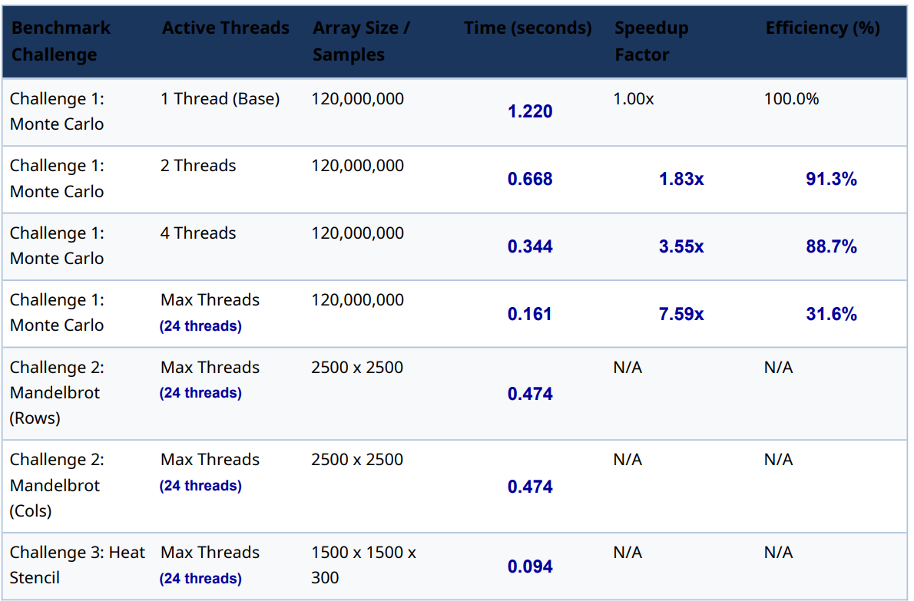
Sorry teacher ,It was easier to make new table than fill that table (really uncomfartable)

Instructor – sufyan.mustafa@sdu.edu.kz

